|  |  |  |  |  |  |  |  |  |
| --- | --- | --- | --- | --- | --- | --- | --- | --- |
| $$α$$ | 0 $°$ | 30 $°$ | 45 $°$ | 60 $°$ | 90 $°$ | 180 $°$ | 270 $°$ | 360 $°$ |
| sin | $$\frac{\sqrt{0}}{2}=0$$ | $$\frac{1}{2}$$ | $$\frac{\sqrt{2}}{2}$$ | $$\frac{\sqrt{3}}{2}$$ | $$\frac{\sqrt{4}}{2}=1$$ | $$0$$ | $$-1$$ | $$\frac{\sqrt{0}}{2}=0$$ |
| cos | $$1$$ | $$\frac{\sqrt{3}}{2}$$ | $$\frac{\sqrt{2}}{2}$$ | $$\frac{1}{2}$$ | $$0$$ | $$-1$$ | $$0$$ | $$1$$ |
| tg | $$0$$ | $$\frac{\sqrt{3}}{3}$$ | $$1$$ | $$1$$ | --- | $$0$$ | --- | $$0$$ |
| ctg | --- | $$\sqrt{3}$$ | $$1$$ | $$1$$ | $$0$$ | --- | $$0$$ | --- |

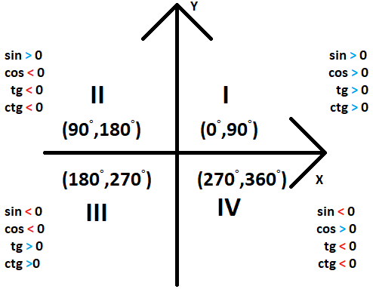

|  |  |
| --- | --- |
| Ćwiartka | Co jest dodatnie |
| I | Wszystkie dodatnie |
| II | Tylko sin |
| III | Tylko tg i ctg |
| IV | Tylko cos |